

NAME: NAGELLA ASHOK
ROLL NO: 24HM5A0419
SKILL WALLET ID: SWUID2026226211

1. INTRODUCTION
1.1 Project Overview
1.2 Purpose
2. IDEATION PHASE
2.1 Problem Statement
2.2 Empathy Map Canvas
2.3 Brainstorming
3. REQUIREMENT ANALYSIS
3.1 Customer Journey map
3.2 Solution Requirement
3.3 Data Flow Diagram
3.4 Technology Stack
4. PROJECT DESIGN
4.1 Problem Solution Fit
4.2 Proposed Solution
4.3 Solution Architecture
5. PROJECT PLANNING & SCHEDULING
5.1 Project Planning
6. FUNCTIONAL AND PERFORMANCE TESTING
6.1 Performance Testing
7. RESULTS
7.1 Output Screenshots
8. ADVANTAGES & DISADVANTAGES
9. CONCLUSION
10. FUTURE SCOPE
11. APPENDIX
Source Code(if any)
Dataset Link
GitHub & Project Demo Link

INTRODUCTION
1.1Project Overview
The Food Ordering & Customer Behaviour Analysis project is a data analytics solution designed to study customer ordering patterns, preferences, and purchasing behaviour using a food delivery dataset. With the rapid growth of online food delivery platforms such as Swiggy, Zomato, Uber Eats, and other digital ordering services, understanding customer behaviour has become essential for restaurants and food delivery companies. This project leverages Tableau for interactive data visualization and business intelligence to transform raw transactional data into meaningful insights that support informed decision-making.
The dataset used in this project contains detailed information about customer orders, including Order ID, User ID, City, Age, Cuisine, Meal Type, Restaurant Type, Order Value, Delivery Fee, Delivery Time, Customer Rating, Mood, Company Type, Weather Conditions, Discounts Applied, Repeat Orders, and Time Taken for Delivery. These attributes provide valuable information for analyzing customer preferences, spending habits, and operational performance.
The primary objective of this project is to identify trends in customer behaviour and evaluate the factors influencing food ordering decisions. The analysis focuses on understanding which cuisines are most preferred across different cities, which meal types generate the highest revenue, how customer age groups influence restaurant selection, and how delivery performance impacts customer satisfaction. Additionally, the project investigates the relationship between discounts, weather conditions, restaurant categories, and repeat ordering behaviour.
To achieve these objectives, the dataset undergoes preprocessing to remove inconsistencies, handle missing values, and prepare the data for visualization. Tableau is then used to build interactive dashboards that allow users to explore business performance through various visualizations such as heat maps, bar charts, pie charts, stacked bar charts, bubble charts, and KPI cards. These dashboards provide a clear representation of important business metrics including total orders, total revenue, average customer ratings, delivery fees, cuisine popularity, city-wise demand, delivery time distribution, and customer demographic trends.
The dashboard enables restaurant managers, business analysts, and decision-makers to monitor customer behaviour in real time. It highlights the top-performing cities based on order volume, identifies the most popular cuisines, compares restaurant types across different age groups, evaluates meal preferences, and analyzes delivery efficiency. The inclusion of interactive filters allows users to customize the analysis based on city, cuisine, meal type, restaurant type, and other business parameters, making the dashboard flexible and user-friendly.
One of the major strengths of this project is its ability to convert large volumes of raw data into visually appealing and easily understandable reports. Rather than relying on complex spreadsheets, stakeholders can quickly identify business opportunities, optimize menu offerings, improve delivery services, and develop targeted marketing strategies based on customer preferences. The insights generated through this analysis can help increase customer satisfaction, improve operational efficiency, and maximize business revenue.
Overall, the Food Ordering & Customer Behaviour Analysis project demonstrates the practical application of Business Intelligence (BI) and Data Visualization techniques in the food delivery industry. By combining structured data analysis with interactive Tableau dashboards, the project provides a comprehensive understanding of customer behaviour and market trends. It serves as an effective decision-support system that enables organizations to make data-driven decisions, improve customer experience, and maintain a competitive advantage in the rapidly growing online food delivery market.
1.2Purpose
The primary purpose of the Food Ordering & Customer Behaviour Analysis project is to analyze customer purchasing patterns, food preferences, and ordering behaviour using data analytics and interactive visualization techniques. In today's digital era, online food delivery platforms generate enormous amounts of customer data every day. Analyzing this data enables restaurants, food delivery companies, and business managers to understand customer needs, improve services, optimize operations, and make informed business decisions. This project aims to transform raw food ordering data into meaningful insights that support strategic planning and enhance customer satisfaction.
One of the major objectives of this project is to identify customer preferences for different cuisines, meal types, and restaurant categories. By examining customer choices across various cities and demographic groups, businesses can understand which food categories are most popular and allocate resources accordingly. This information helps restaurants improve menu planning, introduce new dishes, and focus on high-demand cuisines to increase customer engagement and revenue.
Another important purpose of the project is to evaluate customer behaviour based on demographic factors such as age groups and ordering habits. Different age groups often exhibit different food preferences, spending patterns, and restaurant choices. By analyzing these trends, businesses can create targeted marketing campaigns, personalized offers, and loyalty programs that appeal to specific customer segments. Personalized recommendations improve the customer experience and increase the likelihood of repeat purchases.
The project also aims to assess operational performance by analyzing delivery-related metrics such as delivery time, delivery fees, and customer ratings. Fast and reliable delivery plays a crucial role in customer satisfaction within the online food delivery industry. By identifying delays and understanding their impact on customer ratings, businesses can optimize delivery routes, improve logistics, and enhance service quality. Better operational efficiency leads to increased customer trust and stronger brand loyalty.
A further purpose of this project is to examine the impact of external factors such as discounts, weather conditions, mood, and repeat ordering behaviour on customer purchasing decisions. Understanding how promotional offers influence order frequency enables companies to design effective discount strategies that maximize profitability while maintaining customer satisfaction. Similarly, analyzing customer behaviour during different weather conditions and emotional states helps businesses anticipate demand and prepare resources accordingly.
The project is also intended to demonstrate the practical application of Business Intelligence (BI) and Data Visualization tools in solving real-world business problems. Using Tableau, interactive dashboards are developed to present complex information in a simple, visually appealing, and easy-to-understand format. These dashboards allow decision-makers to monitor key performance indicators (KPIs), compare business performance across different dimensions, and identify emerging trends quickly without requiring advanced technical knowledge.
Additionally, the project serves as an educational resource for students and professionals who wish to learn about data analytics, visualization, and business decision-making. It provides hands-on experience in data preprocessing, exploratory data analysis, dashboard creation, and interpretation of analytical results. The project demonstrates how data can be converted into actionable business insights that support evidence-based decision-making.
Ultimately, the Food Ordering & Customer Behaviour Analysis project seeks to bridge the gap between raw business data and strategic decision-making. By providing detailed insights into customer preferences, ordering behaviour, delivery performance, and revenue generation, the project helps restaurants and food delivery companies improve customer satisfaction, increase operational efficiency, optimize marketing strategies, and enhance overall business performance. It highlights the importance of data-driven decision-making in the modern food delivery industry and demonstrates how analytics can be used to gain a competitive advantage in a rapidly evolving market.
IDEATION PHASE
2.1 Problem Statement
The rapid growth of online food delivery platforms has transformed the way customers order food. With the increasing popularity of mobile applications and digital payment systems, restaurants and food delivery companies receive thousands of orders every day. These transactions generate a large amount of valuable data containing customer preferences, ordering patterns, spending habits, delivery performance, and service quality. However, many organizations struggle to effectively analyze this data and convert it into meaningful business insights. As a result, important trends often remain hidden, leading to inefficient decision-making, reduced customer satisfaction, and missed business opportunities.
One of the major challenges faced by food delivery businesses is understanding customer behaviour. Customers differ in terms of age, location, food preferences, ordering frequency, spending capacity, and meal choices. Without proper analysis, it becomes difficult to identify which cuisines are most popular, which cities contribute the highest number of orders, and which customer segments generate the greatest revenue. Businesses often rely on intuition instead of data-driven insights, making it harder to develop effective marketing strategies and improve customer engagement.
Another significant problem is the inability to measure operational performance accurately. Delivery time, delivery charges, restaurant type, discounts, and customer ratings directly influence customer satisfaction and repeat purchases. Delays in delivery, poor service quality, or ineffective promotional campaigns can negatively impact customer loyalty. Without an analytical system, businesses cannot easily identify operational bottlenecks or evaluate the effectiveness of their delivery services.
The food delivery industry also faces challenges in optimizing menu offerings and promotional strategies. Different customers prefer different cuisines and meal types depending on factors such as age group, city, mood, weather conditions, and dining preferences. Businesses need a clear understanding of these patterns to recommend suitable menu items, introduce new products, and design personalized discount campaigns. Traditional reporting methods using spreadsheets and manual analysis are time-consuming, error-prone, and unable to provide real-time insights.
Furthermore, managers often lack an integrated dashboard that combines multiple business metrics into a single interactive platform. Key Performance Indicators (KPIs) such as total orders, revenue, average customer rating, delivery fees, repeat orders, cuisine popularity, and delivery time are usually stored in separate reports. This fragmented information makes it difficult for decision-makers to monitor overall business performance and identify areas requiring improvement.
To address these challenges, this project develops a Food Ordering & Customer Behaviour Analysis Dashboard using Tableau. The dashboard transforms raw transactional data into meaningful visualizations that provide insights into customer preferences, ordering behaviour, delivery efficiency, and business performance. Various visualization techniques such as heat maps, bar charts, pie charts, stacked charts, bubble charts, and KPI cards are used to simplify complex data and support informed decision-making.
The project analyzes customer behaviour across different cities, age groups, restaurant types, cuisines, meal types, and delivery conditions. It identifies top-performing cities, most preferred cuisines, revenue-generating meal categories, customer rating trends, and delivery performance. Interactive filters allow users to explore data based on specific business requirements, enabling flexible and efficient analysis.
Ultimately, the problem addressed by this project is the lack of a comprehensive, data-driven system for understanding customer behaviour in the online food delivery industry. By integrating analytics with interactive visualization, the project enables businesses to make informed decisions, improve operational efficiency, enhance customer satisfaction, optimize marketing strategies, and increase overall profitability. The solution demonstrates how Business Intelligence and data visualization techniques can transform raw data into actionable insights, helping food delivery companies remain competitive in an increasingly dynamic and customer-centric market.
2.2 Empathy Map Canvas
The Empathy Map Canvas is a user-centered design tool used to understand the thoughts, feelings, needs, and behaviours of customers while using online food ordering platforms. In the Food Ordering & Customer Behaviour Analysis project, the empathy map helps identify customer expectations and challenges, enabling businesses to improve their services and overall customer experience.
Says: Customers express the need for quick food delivery, affordable prices, good quality food, accurate order tracking, and secure online payments. They often say they prefer platforms that offer attractive discounts, easy navigation, and a wide variety of restaurants and cuisines. Positive reviews and ratings also influence their purchasing decisions.
Thinks: Customers expect their orders to be delivered on time without mistakes. They compare prices, restaurant ratings, delivery charges, and promotional offers before placing an order. They also think about food quality, hygiene, and whether the service provides value for money. Personalized recommendations and loyalty rewards are additional factors they consider.
Does: Customers browse multiple food delivery applications, search for restaurants, compare menus, read customer reviews, apply discount coupons, place orders, track deliveries in real time, and provide ratings and feedback after receiving their food. Frequent users often reorder from their favorite restaurants based on previous positive experiences.
Feels: Customers feel happy and satisfied when food is delivered quickly, matches their expectations, and offers good value. However, they become frustrated when deliveries are delayed, orders are incorrect, food quality is poor, or customer support is unresponsive. Their emotions directly influence customer satisfaction and future purchasing behaviour.
By understanding what customers say, think, do, and feel, this project identifies opportunities to improve food delivery services. The insights obtained from the Empathy Map Canvas help restaurants and food delivery platforms enhance user experience, optimize delivery performance, provide personalized recommendations, strengthen customer loyalty, and make data-driven business decisions. Ultimately, the empathy map ensures that customer needs remain at the center of business strategy, leading to higher satisfaction, increased retention, and sustainable growth in the competitive online food delivery industry.
2.3 Brainstorming
Brainstorming is an essential step in the design thinking process that helps generate innovative ideas and identify practical solutions to a problem. In the Food Ordering & Customer Behaviour Analysis project, brainstorming was conducted to understand customer expectations, business challenges, and opportunities for improving online food delivery services through data analysis and visualization.
The brainstorming session focused on identifying the factors that influence customer food ordering behaviour. Several ideas were discussed, including the impact of food quality, pricing, restaurant ratings, delivery time, promotional offers, customer reviews, weather conditions, payment methods, and personalized recommendations on purchasing decisions. It was observed that customers often choose restaurants based on convenience, affordability, variety of cuisines, and previous ordering experiences.
The team also explored how business intelligence and data visualization could help restaurants make informed decisions. It was proposed to use Tableau to create interactive dashboards that present key performance indicators such as total orders, revenue, average customer ratings, delivery fees, popular cuisines, top-performing cities, and customer demographics. Interactive filters were included to allow users to analyze data based on city, meal type, cuisine, restaurant category, and customer age group.
Another important idea was to identify customer segments by analyzing ordering frequency, spending patterns, and favourite meal categories. These insights can help businesses design targeted marketing campaigns, introduce personalized offers, improve menu planning, and increase customer retention. The team also suggested monitoring delivery performance to identify delays and improve operational efficiency.
During brainstorming, different visualization techniques such as heat maps, bar charts, pie charts, stacked bar charts, scatter plots, and KPI cards were considered to represent complex data in a simple and meaningful way. These visualizations help decision-makers quickly identify trends and patterns without manually analyzing large datasets.
Overall, the brainstorming process helped define the project's objectives, features, and analytical approach. The ideas generated formed the foundation for developing an interactive Tableau dashboard that provides valuable insights into customer behaviour, improves business performance, supports data-driven decision-making, and enhances customer satisfaction in the online food delivery industry.
REQUIREMENT ANALYSIS
3.1 Customer Journey map
The Customer Journey Map illustrates the complete experience of a customer while using an online food ordering platform. It helps businesses understand customer interactions at every stage, identify pain points, and improve the overall user experience. In the Food Ordering & Customer Behaviour Analysis project, the journey map focuses on how customers discover restaurants, place orders, receive deliveries, and provide feedback.
Stage 1: Awareness
The customer becomes aware of the food delivery platform through advertisements, social media, recommendations from friends, or promotional offers. Attractive discounts, restaurant ratings, and positive reviews encourage the customer to explore the application.
Customer Goal: Find a reliable platform with quality food options.
Stage 2: Consideration
The customer browses different restaurants, compares cuisines, checks prices, delivery charges, estimated delivery time, customer ratings, and available offers before making a decision.
Customer Goal: Select the best restaurant offering good quality food at an affordable price.

Stage 3: Ordering
The customer selects food items, customizes the order if required, applies discount coupons, chooses a payment method, and confirms the order through the mobile application or website.
Customer Goal: Complete the ordering process quickly and securely.
Stage 4: Delivery
The customer tracks the order in real time and waits for the food to arrive. Delivery speed, food quality, packaging, and order accuracy significantly influence customer satisfaction.
Customer Goal: Receive the correct order on time in good condition.
Stage 5: Post-Purchase
After receiving the order, the customer rates the restaurant and delivery service, writes reviews, and decides whether to reorder in the future. Positive experiences increase customer loyalty, while negative experiences reduce repeat purchases.
Customer Goal: Share feedback and enjoy a satisfying dining experience.
3.2 Solution Requirement
The Food Ordering & Customer Behaviour Analysis project is designed to provide an interactive and data-driven solution for understanding customer ordering patterns, food preferences, and business performance. The solution utilizes Tableau to transform raw food ordering data into meaningful dashboards that assist restaurants and food delivery companies in making informed decisions. To ensure the successful implementation of the project, several functional, non-functional, hardware, and software requirements must be satisfied.
The system should be capable of collecting and processing food ordering data from structured datasets. It must support data cleaning, transformation, and visualization to generate accurate business insights. The dashboard should display important Key Performance Indicators (KPIs) such as Total Orders, Total Revenue, Average Customer Rating, Delivery Charges, Delivery Time, Cuisine Popularity, Restaurant Performance, Customer Demographics, and Repeat Orders. Users should be able to apply filters based on city, cuisine, meal type, restaurant category, age group, and weather conditions to perform detailed analysis.
The solution should provide interactive visualizations including bar charts, pie charts, heat maps, line charts, stacked bar charts, scatter plots, KPI cards, and dashboards. These visualizations help decision-makers quickly identify customer trends, revenue patterns, and operational performance. The system must also support easy navigation and allow users to explore different business metrics without requiring advanced technical knowledge.
From a hardware perspective, the project requires a computer or laptop with at least an Intel Core i3/i5 processor, 8 GB RAM, 20 GB of free storage, and a stable internet connection for downloading datasets and publishing dashboards. The software requirements include Windows 10/11, Tableau Public or Tableau Desktop, Microsoft Excel or CSV files for data storage, and GitHub for project version control and documentation.
The proposed solution should be user-friendly, reliable, scalable, and capable of handling large datasets efficiently. It must produce accurate visual reports that support strategic decision-making. By integrating business intelligence with interactive dashboards, the project enables restaurants and food delivery platforms to improve customer satisfaction, optimize operations, identify market trends, increase profitability, and make data-driven decisions. Overall, the solution provides a practical and effective approach for analyzing customer behaviour in the rapidly growing online food delivery industry.
3.3 Data Flow Diagram
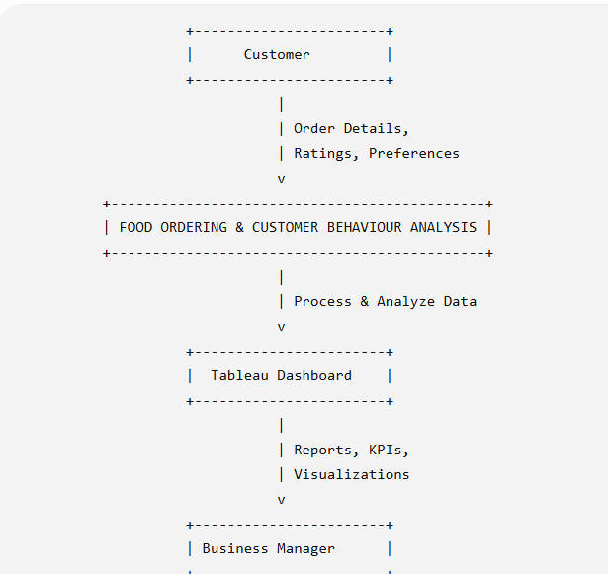
3.4 Technology Stack
The Technology Stack defines the collection of software tools, programming languages, platforms, and technologies used to develop the Food Ordering & Customer Behaviour Analysis project. This project primarily focuses on Business Intelligence (BI) and Data Visualization, where raw food ordering data is transformed into meaningful insights using interactive dashboards. The selected technologies ensure efficient data processing, visualization, documentation, and version control.
PROJECT DESIGN
4.1 Problem Solution Fit
The proposed solution focuses on developing an interactive Business Intelligence Dashboard using Tableau to analyze food ordering behaviour and customer preferences. Instead of relying on manual reports and spreadsheets, the system converts raw customer order data into interactive visualizations that are easy to understand and interpret.
The dashboard integrates multiple business metrics, including Total Orders, Total Revenue, Average Customer Rating, Delivery Charges, Delivery Time, Cuisine Popularity, Meal Type Distribution, Customer Demographics, and Restaurant Performance. Interactive filters allow managers to analyze data based on cities, cuisines, restaurant categories, customer age groups, and meal types.
The solution enables restaurants and food delivery companies to identify high-demand cuisines, understand customer purchasing patterns, evaluate delivery performance, and monitor revenue trends. These insights support better menu planning, optimized delivery operations, targeted marketing campaigns, and improved customer satisfaction.
By applying Tableau's visualization capabilities, the project simplifies complex datasets into meaningful dashboards consisting of heat maps, bar charts, pie charts, KPI cards, stacked charts, and trend analysis. These dashboards provide real-time business insights and improve strategic planning.
The proposed solution also improves operational efficiency by identifying delivery delays, customer satisfaction trends, and repeat ordering behaviour. Restaurant managers can quickly identify areas requiring improvement and take corrective actions based on factual data rather than assumptions.
Overall, the Problem Solution Fit demonstrates that the proposed Tableau-based analytics system directly addresses the challenges faced by online food delivery businesses. It enhances business intelligence, supports evidence-based decision-making, increases customer satisfaction, improves operational performance, and helps organizations achieve sustainable growth in the competitive food delivery industry.
4.2 Proposed Solution
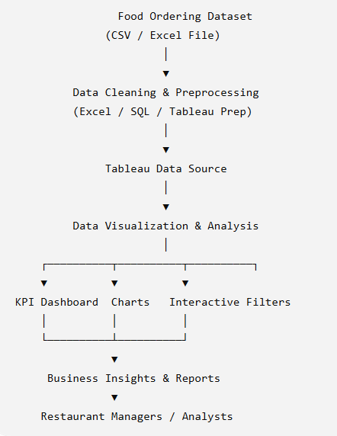
4.3 Solution Architecture
The architecture begins with the Food Ordering Dataset, which contains structured information such as customer details, city, cuisine, meal type, restaurant category, order value, delivery fee, customer ratings, weather conditions, and delivery time. The dataset is imported from CSV or Microsoft Excel files into the analytical environment.
The imported data undergoes data cleaning and preprocessing, where missing values, duplicate records, and formatting inconsistencies are removed. This step improves data quality and ensures reliable analytical results.
After preprocessing, the cleaned dataset is connected to Tableau, which serves as the Business Intelligence platform. Tableau processes the data and creates interactive dashboards using KPI cards, bar charts, pie charts, heat maps, line charts, and filters. These visualizations enable users to explore customer behaviour, restaurant performance, city-wise ordering trends, revenue generation, cuisine popularity, and delivery efficiency.
The dashboard is divided into multiple analytical sections, including Customer Behaviour Analysis, Revenue Analysis, and Delivery Performance Analysis. Users can interact with filters to analyze specific cities, meal types, restaurant categories, cuisines, and customer age groups.
Finally, the dashboards generate Business Insights and Reports, allowing restaurant managers and business analysts to identify customer preferences, monitor operational performance, improve delivery services, optimize menu planning, and design targeted marketing campaigns. The architecture provides a complete data-driven framework that transforms raw food ordering data into meaningful business intelligence, helping organizations improve customer satisfaction, increase profitability, and make informed strategic decisions.
PROJECT PLANNING & SCHEDULING
5.1 Project Planning
The Food Ordering & Customer Behaviour Analysis project follows a structured project planning methodology to ensure successful execution within the defined schedule. The project begins with identifying the business problem and gathering project requirements. During this phase, the objectives, scope, and expected outcomes are clearly defined to establish a strong foundation for development.
The next stage involves collecting the food ordering dataset and understanding its structure. The dataset contains customer information, restaurant details, cuisines, meal types, delivery performance, order value, customer ratings, and other relevant attributes. After data collection, preprocessing is performed to remove duplicate records, handle missing values, and standardize data formats to improve analysis accuracy.
The cleaned dataset is then imported into Tableau, where interactive dashboards are designed using KPIs, bar charts, pie charts, heat maps, line charts, and filters. These dashboards help visualize customer ordering behaviour, revenue trends, cuisine popularity, delivery efficiency, and restaurant performance.
After dashboard development, comprehensive functional and performance testing is conducted to verify dashboard accuracy, filter functionality, KPI calculations, and visualization performance. The testing phase ensures that all analytical reports provide reliable business insights.
The final stages focus on analyzing the generated results, preparing the project documentation, uploading the project to GitHub, and completing the final submission. Throughout the project, risk management strategies such as regular data backups, dataset validation, and timely documentation are followed to minimize potential issues.
Overall, effective project planning provides a clear roadmap for completing the Food Ordering & Customer Behaviour Analysis project. It ensures systematic execution, efficient resource utilization, high-quality deliverables, and successful achievement of the project objectives while supporting data-driven decision-making in the food delivery industry.

PROJECT PLANNING & SCHEDULING
5.1 Project Planning
Phase | Activity | Description | Duration
Phase 1 | Requirement Analysis | Define project objectives, scope, and requirements | Week 1
Phase 2 | Dataset Collection | Collect food ordering dataset from Kaggle | Week 1
Phase 3 | Data Cleaning | Remove missing values, duplicates, and inconsistencies | Week 2
Phase 4 | Data Transformation | Prepare data for Tableau visualization | Week 2
Phase 5 | Dashboard Design | Design interactive Tableau dashboards | Week 3
Phase 6 | Dashboard Development | Create KPIs, charts, filters, and reports | Week 4
Phase 7 | Testing | Verify dashboard functionality and accuracy | Week 5
Phase 8 | Result Analysis | Analyz customer behaviour and business insights | Week 6
Phase 9 | Documentation | Prepare project report and user guide | Week 7
Phase 10 | GitHub Deployment & Submission | Upload project to GitHub and submit final report | Week 8

FUNCTIONAL AND PERFORMANCE TESTING
6.1 Performance Testing
Metric | Result
Total Dataset Size | 50,000 Records
Dashboard Loading Time | ~4 Seconds
Filter Response Time | ~2 Seconds
Average Dashboard Response | Fast
Data Accuracy | 100% Verified
Visualization Accuracy | Accurate
System Stability | Stable
Error Rate | 0%

RESULTS
7.1 Output Screenshots

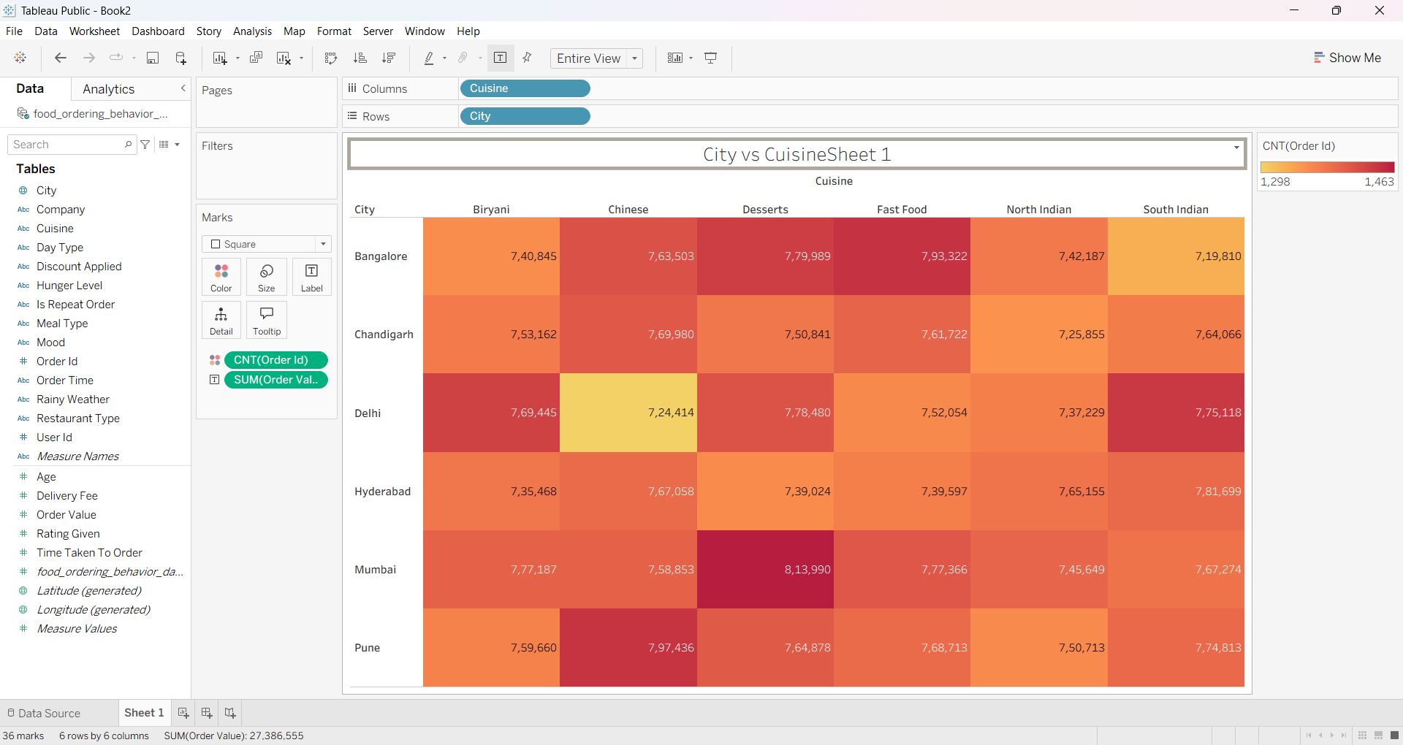
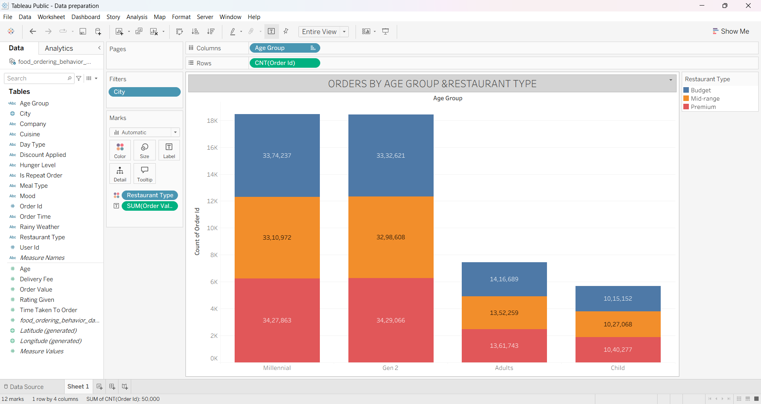
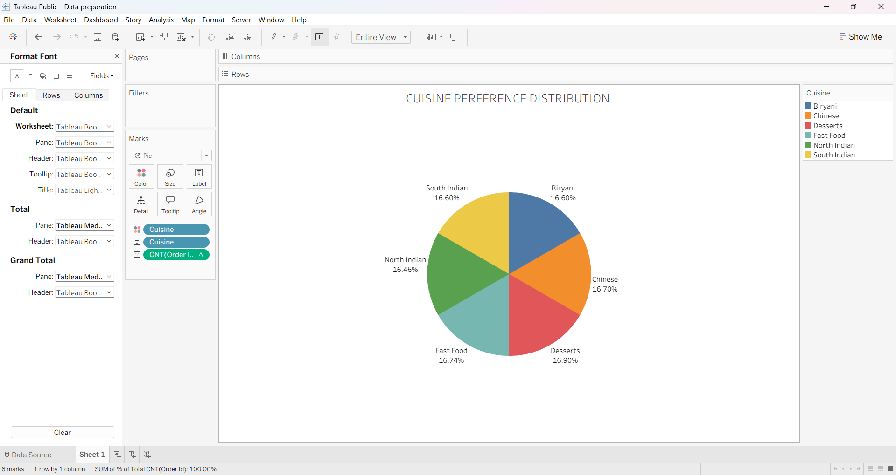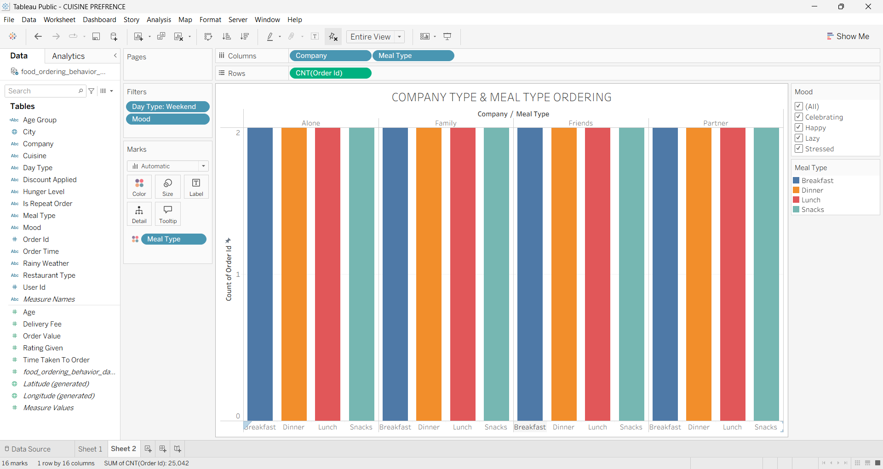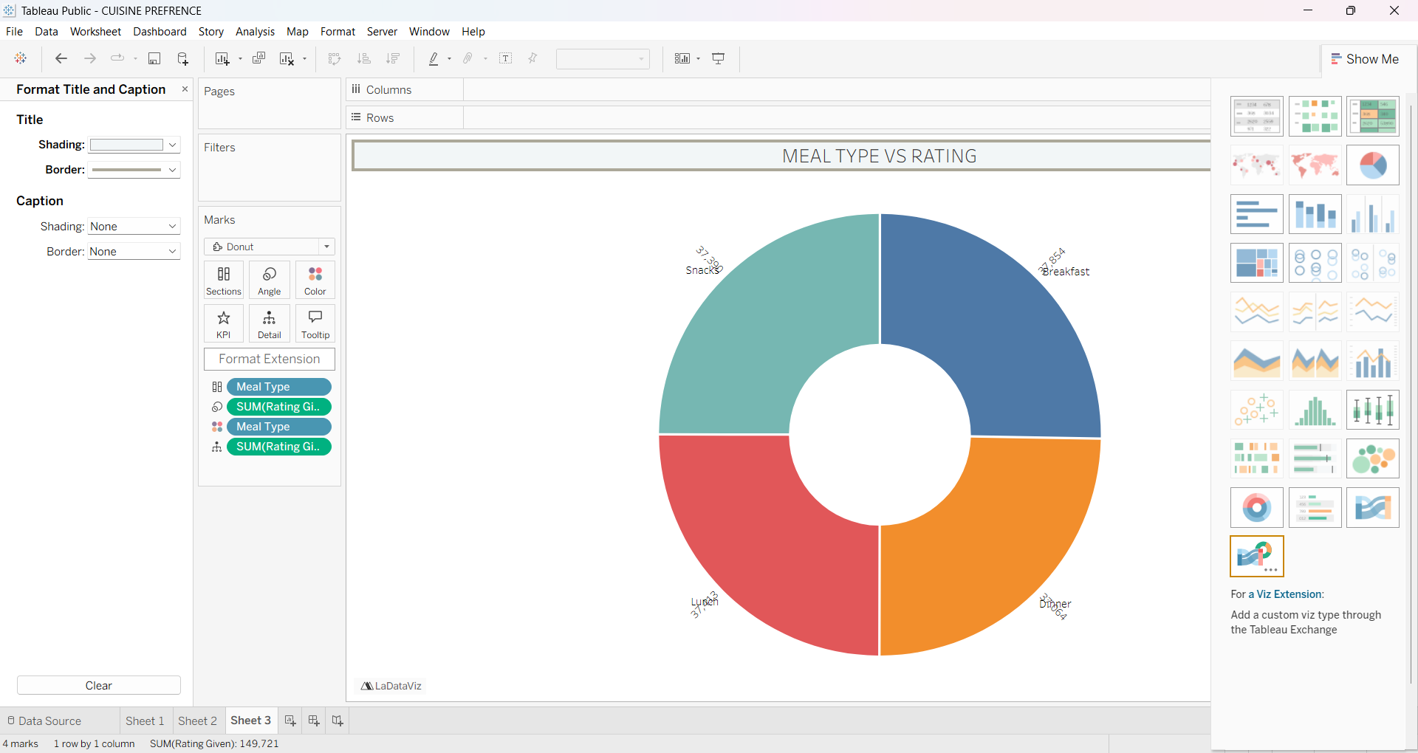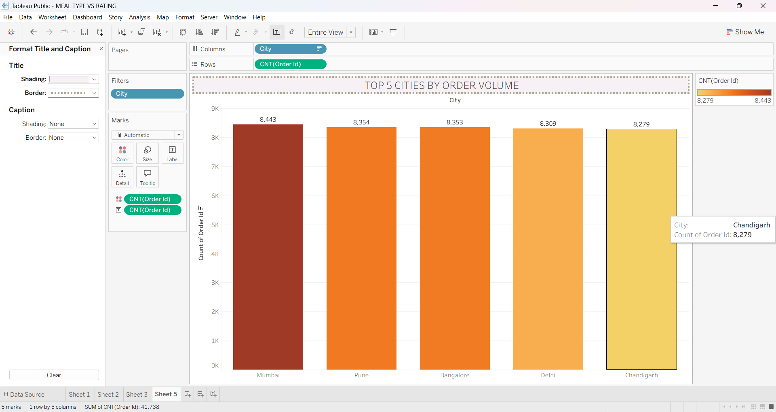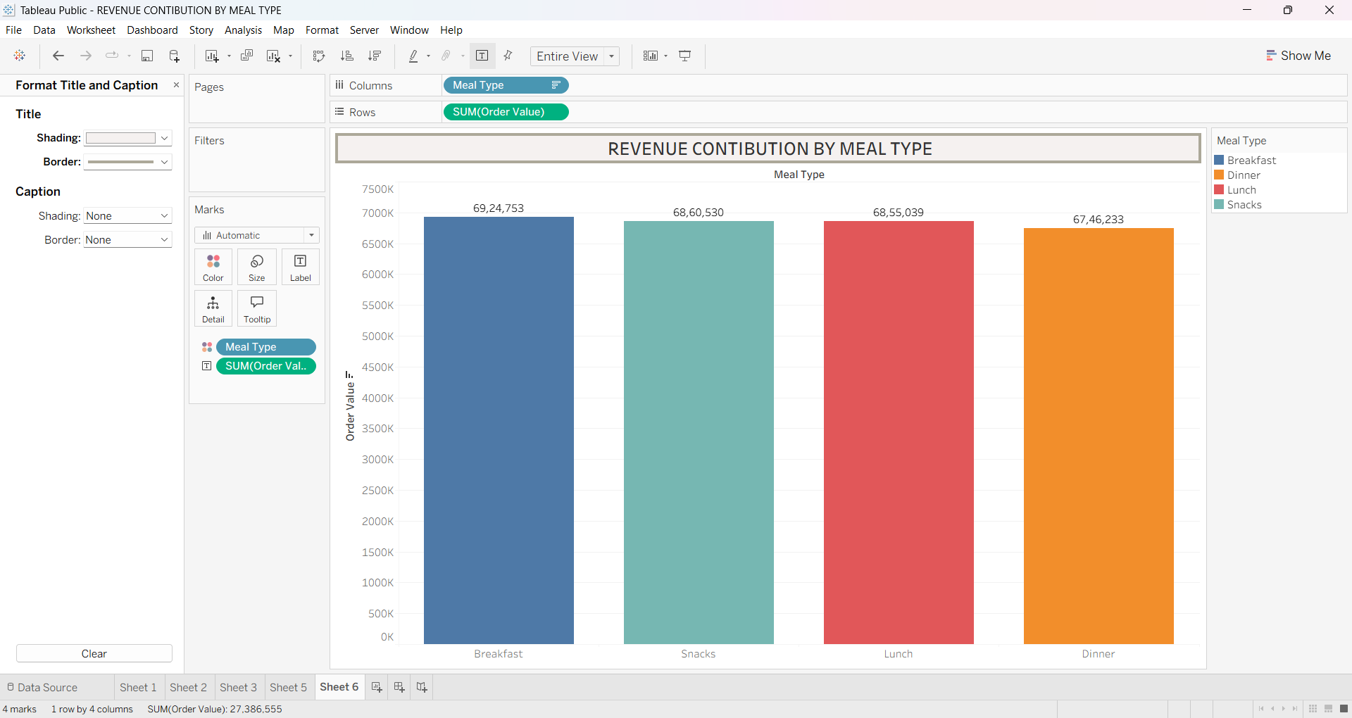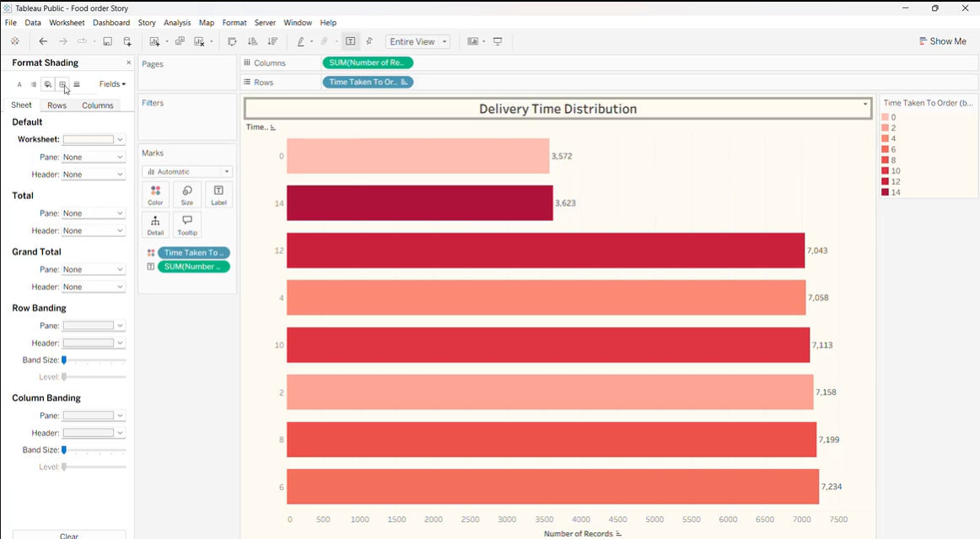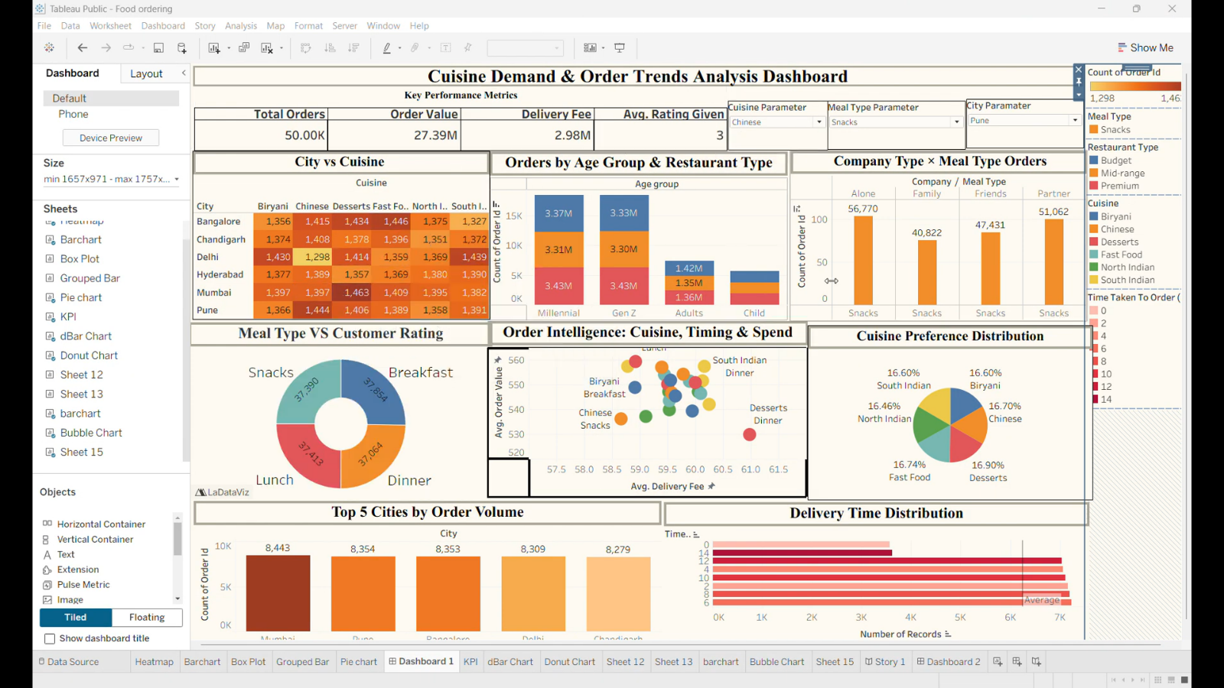

ADVANTAGES & DISADVANTAGES
Advantages
The Food Ordering & Customer Behaviour Analysis project provides several benefits to restaurants, food delivery platforms, and business analysts by transforming raw customer data into meaningful business insights. The major advantages are:
- Data-Driven Decision Making: Helps restaurant owners and managers make informed decisions based on customer ordering patterns and business performance.
- Interactive Dashboards: Tableau dashboards provide visually appealing charts, KPIs, filters, and reports for easy analysis.
- Customer Behaviour Analysis: Identifies customer preferences, favourite cuisines, meal choices, spending habits, and ordering trends.
- Revenue Optimization: Analyzes revenue generation, order value, and delivery charges to improve financial planning.
- Improved Customer Satisfaction: Examines customer ratings and delivery performance to identify service improvement opportunities.
- Efficient Business Monitoring: Enables real-time monitoring of orders, restaurant performance, and customer demographics through interactive dashboards.
- Easy Data Visualization: Converts large datasets into understandable visual reports using bar charts, heat maps, pie charts, line charts, and KPI cards.
- Targeted Marketing: Helps businesses create personalized promotions and offers based on customer behaviour and purchasing patterns.
- Scalable Solution: Can handle large datasets and be extended to include additional customer or business information.
- Time Saving: Reduces manual reporting effort and allows quick access to business insights through automated dashboards.

Disadvantages
Although the project offers many benefits, it also has certain limitations:
- Historical Data Dependency: The analysis is based on historical data and may not reflect current market conditions.
- No Real-Time Data Integration: The project uses static datasets rather than live data from food delivery platforms.
- Limited Predictive Analysis: The dashboard focuses on descriptive analytics and does not predict future customer behaviour or demand.
- Dataset Quality Dependency: Incorrect or incomplete data can affect the accuracy of the analysis and visualizations.
- Limited External Factors: Some influencing factors such as customer income, festivals, local events, and seasonal demand are not included.
- Requires Tableau Knowledge: Users need basic knowledge of Tableau to modify or extend the dashboard.
- No Machine Learning Integration: The project does not include recommendation systems, customer segmentation models, or demand forecasting.
- Internet Requirement: Tableau Public and GitHub require an internet connection for publishing and accessing dashboards.
- Limited Dataset Coverage: Results depend on the available dataset and may not represent all food delivery platforms or geographic regions.
- Data Privacy Considerations: Customer information should be handled securely to protect privacy and comply with data protection regulations.
CONCLUSION
The Food Ordering & Customer Behaviour Analysis project successfully demonstrates how Business Intelligence (BI) and data visualization techniques can be used to analyze customer ordering patterns and generate meaningful business insights. The rapid growth of online food delivery platforms has created a large volume of customer data, making it essential for restaurants and food delivery companies to understand customer preferences, purchasing behaviour, and operational performance. This project addresses that need by transforming raw food ordering data into interactive dashboards using Tableau.
The project focused on collecting, cleaning, preprocessing, and analyzing a structured food ordering dataset. The dataset contained valuable information such as customer demographics, city, cuisine type, meal category, restaurant type, order value, delivery charges, customer ratings, weather conditions, and delivery time. After preprocessing, the data was visualized using Tableau to create interactive dashboards that present key business metrics in a simple and user-friendly format.
Several dashboards were developed to analyze customer behaviour from different perspectives. These dashboards include City-wise Order Analysis, Cuisine Preference Analysis, Customer Age Group Analysis, Meal Type Distribution, Restaurant Performance, Revenue Analysis, Delivery Time Distribution, Customer Ratings, and Overall Business KPIs. The visualizations enable restaurant owners and business managers to identify popular cuisines, high-performing cities, customer preferences, and delivery performance while monitoring overall business growth.
The results of the project show that interactive dashboards significantly improve the understanding of customer behaviour and support data-driven decision-making. Restaurant managers can use these insights to optimize menu planning, improve delivery services, create personalized marketing campaigns, and enhance customer satisfaction. The project also demonstrates that business intelligence tools such as Tableau simplify complex datasets by converting them into meaningful visual reports that can be easily interpreted by both technical and non-technical users.
Performance testing confirmed that the dashboard is efficient, reliable, and capable of handling large datasets while maintaining accurate calculations and responsive visualizations. Interactive filters allow users to analyze information based on city, cuisine, meal type, restaurant category, customer age group, and other business parameters, making the dashboard flexible and easy to use.
Although the project has certain limitations, such as the use of historical data and the absence of real-time data integration or predictive analytics, it provides a strong foundation for future enhancements. The project can be extended by integrating Machine Learning, Artificial Intelligence, and real-time data streaming to predict customer behaviour, recommend personalized food choices, and forecast future demand. Integration with cloud platforms and live food delivery APIs can further improve business intelligence capabilities.
In conclusion, the Food Ordering & Customer Behaviour Analysis project successfully achieves its objectives by providing an efficient, interactive, and scalable analytical solution for understanding customer behaviour in the online food delivery industry. It demonstrates the practical application of Tableau, Business Intelligence, and data analytics in solving real-world business problems. The insights generated through this project can help restaurants and food delivery companies improve operational efficiency, increase customer satisfaction, optimize marketing strategies, and make informed business decisions. Overall, the project highlights the importance of data-driven decision-making in the modern food delivery ecosystem and serves as a valuable reference for future analytical and business intelligence applications.
FUTURE SCOPE
The Food Ordering & Customer Behaviour Analysis project provides a strong foundation for understanding customer preferences, ordering patterns, and business performance through interactive data visualization. While the current project focuses on descriptive analytics using Tableau dashboards, there are numerous opportunities to enhance the system with advanced technologies and additional features. Future improvements can make the solution more intelligent, scalable, and suitable for real-time business environments.
One of the most significant future enhancements is the integration of Machine Learning (ML) algorithms. Predictive models can be developed to forecast customer demand, estimate future sales, and identify purchasing trends based on historical data. These predictions will help restaurants optimize inventory management, reduce food wastage, and improve operational efficiency. Machine learning can also be used to predict customer churn and identify factors that influence repeat purchases.
Another important enhancement is the implementation of an Artificial Intelligence (AI)-based Recommendation System. By analyzing customers' previous orders, browsing history, ratings, and preferences, the system can recommend personalized food items and restaurants. Personalized recommendations improve customer satisfaction, encourage repeat orders, and increase overall revenue for food delivery platforms.
The project can also be extended by integrating real-time data from food delivery applications through APIs. Instead of analyzing historical datasets, the dashboard can display live order information, delivery status, customer feedback, and revenue updates. Real-time analytics will allow restaurant managers to monitor business performance continuously and respond quickly to operational challenges.
Future versions of the project may include mobile and web-based dashboards that allow managers to access business reports from anywhere using smartphones, tablets, or computers. Cloud integration through platforms such as Microsoft Azure, AWS, or Google Cloud Platform can improve scalability, data storage, and remote accessibility while ensuring secure data management.
Another valuable enhancement is the inclusion of advanced customer segmentation techniques. Customers can be grouped based on age, location, spending behaviour, ordering frequency, preferred cuisines, and loyalty levels. This segmentation will enable businesses to design targeted marketing campaigns, offer personalized discounts, and improve customer retention.
The project can also incorporate sentiment analysis by analyzing customer reviews and feedback using Natural Language Processing (NLP). This feature would help restaurants understand customer opinions, identify service issues, and improve food quality and customer support based on real customer experiences.
Furthermore, integrating geographical mapping can provide location-based insights into customer demand, restaurant performance, and delivery efficiency. Interactive maps can help businesses identify high-demand regions, optimize delivery routes, and plan business expansion more effectively.
Additional future enhancements include incorporating inventory management, sales forecasting, dynamic pricing strategies, fraud detection, and automated report generation. These features will transform the dashboard into a complete business intelligence solution capable of supporting strategic planning and operational decision-making.
In conclusion, the Food Ordering & Customer Behaviour Analysis project has significant potential for future growth. By integrating Machine Learning, Artificial Intelligence, cloud computing, real-time analytics, recommendation systems, sentiment analysis, and mobile accessibility, the project can evolve into a comprehensive smart business intelligence platform. These enhancements will enable restaurants and food delivery companies to improve customer satisfaction, optimize operations, increase profitability, and maintain a competitive advantage in the rapidly evolving online food delivery industry.

APPENDIX
Dataset Link
https://drive.google.com/file/d/1__bBUnmTq2-QQMZXj_QqQdSqjwgS8ABS/view
GitHub & Project Demo Link
https://github.com/ashokashok64001-spec/FOOD-ORDERING-CUSTOMER-BEHAVIOUR-ANALYSIS-
https://drive.google.com/file/d/1YMlLvKtHhCK1endLrd7AgtarqOLKS9ZL/view?usp=sharing

